https://support.office.com/en-us/article/Tutorial-Create-Amazing-Power-View-Reports-Part-2-361b1fca-4429-42a2-94a2-e4d5f3e7d170?ui=en-US&rs=en-US&ad=US

Tutorial: Create Amazing Power View Reports - Part 2

Part 2

Applies To: Excel 2013

**Abstract:**    At the end of the previous tutorial, [Create Amazing Power View Reports - Part 1](https://support.office.com/en-us/article/Create-Amazing-Power-View-Reports--Part-1-e2842c8f-585f-4a07-bcbd-5bf8ff2243a7), your Excel workbook had three Power View reports and many visualizations, including interactive Map, Pie, Bar, and Column Charts. In this tutorial, you learn how to create additional interactive Power View reports.

Note, too, that when you publish these reports and make them available on SharePoint, these visualizations are just as interactive as they are in this tutorial, for anyone viewing them.

## The sections in this tutorial are the following:

[Create Multiples Charts](https://support.office.com/en-us/article/Tutorial-Create-Amazing-Power-View-Reports-Part-2-361b1fca-4429-42a2-94a2-e4d5f3e7d170?ui=en-US&rs=en-US&ad=US" \l "__toc358109945)

[Build Interactive Reports using Cards and Tiles](https://support.office.com/en-us/article/Tutorial-Create-Amazing-Power-View-Reports-Part-2-361b1fca-4429-42a2-94a2-e4d5f3e7d170?ui=en-US&rs=en-US&ad=US#__toc358109946)

[Create Scatter Charts and Bubble Charts with Time-based Play Visualizations](https://support.office.com/en-us/article/Tutorial-Create-Amazing-Power-View-Reports-Part-2-361b1fca-4429-42a2-94a2-e4d5f3e7d170?ui=en-US&rs=en-US&ad=US#__toc358109947)

[Checkpoint and Quiz](https://support.office.com/en-us/article/Tutorial-Create-Amazing-Power-View-Reports-Part-2-361b1fca-4429-42a2-94a2-e4d5f3e7d170?ui=en-US&rs=en-US&ad=US#__toc358109948)

At the end of this tutorial is a quiz you can take to test your learning. You can also see a list of videos that show many of the concepts and capabilities of Power View in action.

This series uses data describing Olympic Medals, hosting countries, and various Olympic sporting events. The tutorials in this series are the following:

1. [Import Data into Excel 2013, and Create a Data Model](https://support.office.com/en-us/article/Import-Data-into-Excel-2013-and-Create-a-Data-Model-4b4e5ab4-60ee-465e-8195-09ebba060bf0)
2. [Extend Data Model relationships using Excel 2013, Power Pivot, and DAX](https://support.office.com/en-us/article/Extend-Data-Model-relationships-using-Excel-2013-Power-Pivot-and-DAX-cf7197d3-1938-490e-93fb-20371e8dd67a)
3. [Create Map-based Power View Reports](https://support.office.com/en-us/article/Create-Mapbased-Power-View-Reports-62ecd29a-91b8-4e5c-b3b7-4aef9f7ef962)
4. [Incorporate Internet Data, and Set Power View Report Defaults](https://support.office.com/en-us/article/Incorporate-Internet-Data-and-Set-Power-View-Report-Defaults-a0b627f4-edcb-42fa-9815-646077064a7a)
5. [Create Amazing Power View Reports - Part 1](https://support.office.com/en-us/article/Create-Amazing-Power-View-Reports--Part-1-e2842c8f-585f-4a07-bcbd-5bf8ff2243a7)
6. **Create Amazing Power View Reports - Part 2**

We suggest you go through them in order.

These tutorials use Excel 2013 with Power Pivot enabled. For more information on Excel 2013, see [Excel 2013 Quick Start Guide](https://support.office.com/en-us/article/Excel-2013-Quick-Start-Guide-4337fe93-0690-47cb-89a1-8424d5fdd886). For guidance on enabling Power Pivot, see [Power Pivot Add-in](https://support.office.com/en-us/article/Power-Pivot-Addin-a9c2c6e2-cc49-4976-a7d7-40896795d045).

## Create Multiples Charts

In this section, you continue creating interactive visualizations with Power View. This section describes creating a few different types of Multiples charts. Multiples are sometimes also called Trellis Charts.

*Create Interactive Vertical* *Multiples Charts*

To create multiples charts, you begin with another chart, such as a pie chart or a line chart.

1. In Excel, select the **Bar and Column** worksheet. Create a new Power View report by selecting **POWER VIEW > Insert > Power View** from the ribbon. A blank Power View report sheet is created. Rename the report **Multiples**, by right-clicking the tab along the bottom and selecting **Rename** from the menu that appears. You can also double-click the tab to rename it.
2. Expand the **Medals** table in **Power View Fields** and select the Gender and then the Event fields. From the FIELDS area, select the arrow button beside Event, and select *Count (Not Blank)*. The table Power View creates looks like the following screen.  
     
   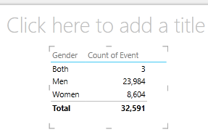
3. From the ribbon, select **DESIGN > Switch Visualization > Other Chart > Pie Chart**. Now your report looks like the following screen.  
     
   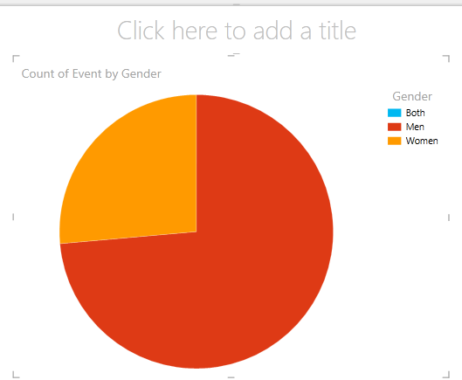
4. You decide it would be interesting to view the number of events by gender over time. One way to view that information is to use multiples. From the **Medal** table, drag Year to the VERTICAL MULTIPLES field. In order to view more multiples, remove the legend from the report by selecting **LAYOUT > Legend > None** from the ribbon.
5. Change the layout so the multiples grid shows six charts wide by six charts tall. With the chart selected, select **LAYOUT > Grid Height > 6** and then **LAYOUT > Grid Width > 6**. Your screen now looks like the following screen.  
     
   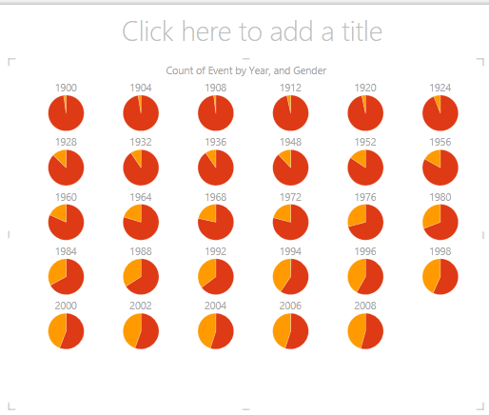
6. The multiples chart type is interactive too. Hover over any pie chart, and information about that slice is displayed. Click any pie slice in the grid, and that selection is highlighted for each chart in the multiple. In the screen below the yellow slice (women) for 1952 was selected, and all other yellow slices are highlighted. When more charts are available than Power View can display in one screen, a vertical scroll bar is displayed along the right edge of the visualization.  
     
   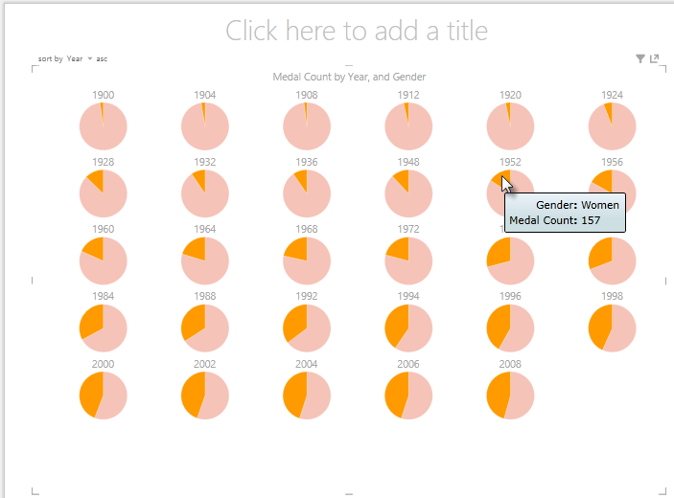

*Create Interactive Horizontal Multiples Charts*

Horizontal charts behave similar to Vertical Multiple Charts.

1. You want to change your Vertical Multiples Charts to Horizontal Verticals. To do so, drag the Year field from the VERTICAL MULTIPLES area into the HORIZONTAL MULTIPLES area, as shown in the following screen.  
     
     
   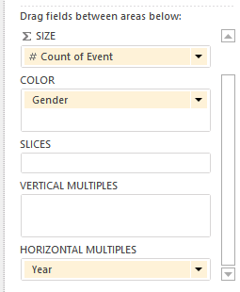
2. The Power View report visualization changes to a Horizontal Multiples Chart. Notice the scroll bar along the bottom of the visualization, shown in the following screen.  
     
   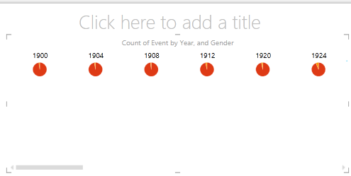

*Create Multiples Line Charts*

Creating line charts as multiples is easy, too. The following steps show you how to create multiple line charts based on the count of medals for each year.

1. Create a new Power View sheet, and rename it **Line Multiples**. From **Power View Fields**, select Medal Count and Year from the **Medals** table. Change the visualization to a line chart by selecting **DESIGN > Other Chart > Line**. Now drag Year to the AXIS area. Your chart looks like the following screen.  
   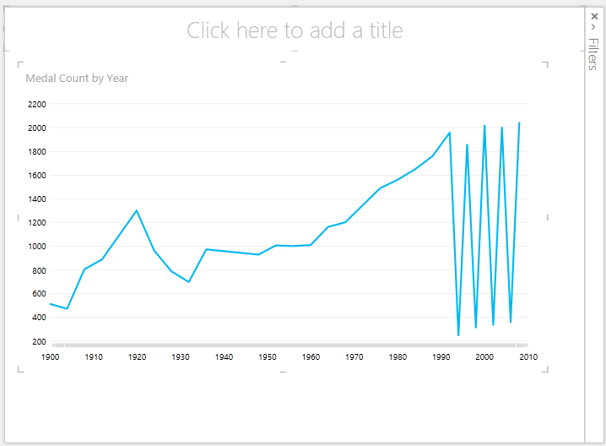
2. Let’s focus on Winter medals. In the **Filters** pane, select CHART, then drag Season from the **Medals** table into the Filters pane. Select Winter, as shown in the following screen.   
     
   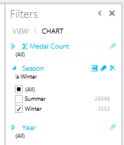
3. To create the multiples line charts, drag NOC\_CountryRegion from the **Medals** table into the VERTICAL MULTIPLES area. Your report now looks like the following screen.  
   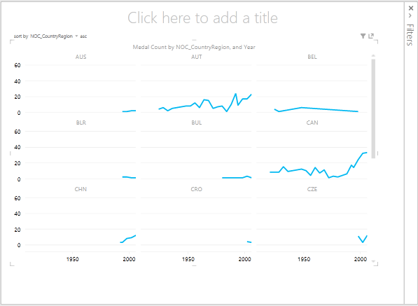
4. You can choose to arrange the multiple charts based on different fields, and in ascending or descending order, by clicking on the selections in the upper left corner of the visualization.

Build Interactive Reports using Cards and Tiles

Tiles and cards convert tables to a series of snapshots that visualize the data, laid out in card format, much like index cards. In the following steps, you use cards to visualize the number of medals awarded in various sports, and then, refine that visualization by tiling the results based on Edition.

*Create Card Visualizations*

1. Create a new Power View Report, and rename it **Cards**. From **Power View Fields**, from the **Disciplines** table, select Discipline. From the **Medals** table, select Distinct Count of Edition, Medal Count, and NOC\_CountryRegion. In the FIELDS area of **Power View Fields**, click the arrow next to NOC\_CountryRegion, and select Count (Distinct).
2. In the ribbon, select **DESIGN > Switch Visualization > Table > Card**. Your table looks like the following screen.  
   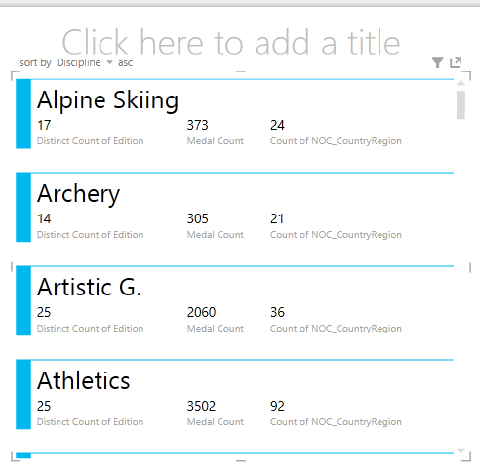
3. With the card visualization selected, select DiscImage from the **DiscImage** table. You may get a security warning that prompts you to click a button to Enable Content in order to get the images to display, as shown in the following screen.   
     
   External Data Connections warning in Excel
4. In the FIELDS area, arrange the fields in the following order: DiscImage, Discipline, Medal Count, Count of NOC\_CountryRegion, and last, Distinct Count of Edition. Your Cards now look similar to the following screen.   
   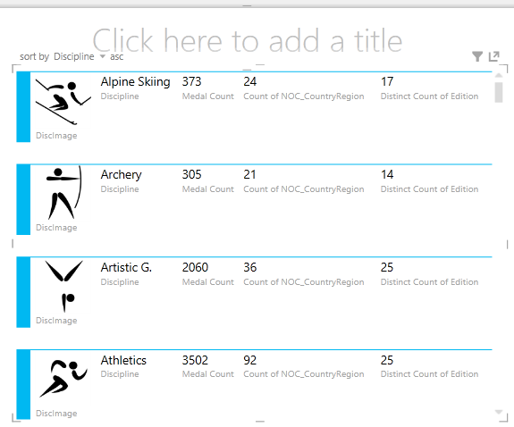

*Use Tiles with Card Visualizations*

1. Reviewing these cards based on the year in which the medals were awarded is easy. In **Power View Fields**, from the **Medals** table, drag the Year field into the TILE BY area. Your visualization now looks like the following screen.   
   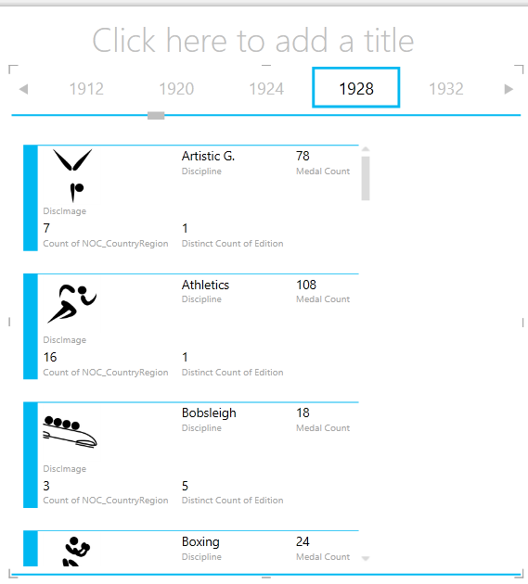
2. Now the cards are tiled by Year, but something else happened as well. The TILE BY field became a container, which at this point only contains the cards you created in the previous steps. We can add to that container, however, and see how using TILE BY can create interactive reports that coordinate the view of your data.
3. Click in the area beside the cards visualization, but still inside the TILE BY container. The **Power View Fields** pane changes to reflect that you are still in the TILE BY container, but you are not in the cards visualization. The following screen shows how this appears in the Power View Fields pane.  
   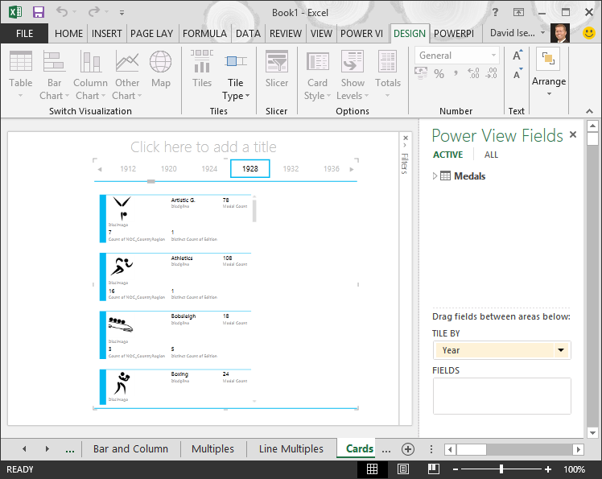
4. In **Power View Fields**, select ALL to show all available tables. From the **Hosts** table, select City, Season, NOC\_CountryRegion, and FlagURL. Then from the ribbon, select **DESIGN > Switch Visualization > Table > Card**. You want the table you just created to fill up more of the available report space, so you decide to change the type of Card visualization. Select **DESIGN > Options > Card Style > Callout**. That’s better. Your report now looks like the following screen.   
   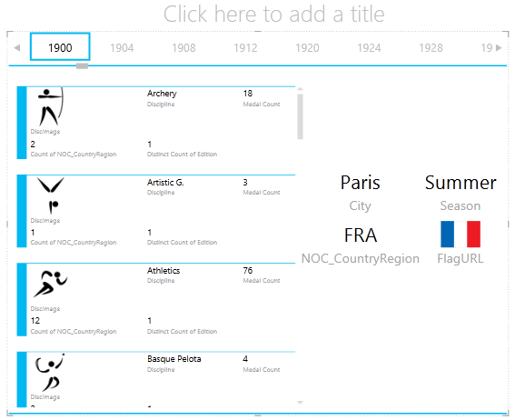
5. Notice how, when you select a different Year from the Tiles along the top of the TILE BY container, the callout card you just created is also synchronized with your selection. That’s because both card visualizations reside within the TILE BY container you created. When you scroll the TILE BY selection and select 2002, for example, your report looks like the following screen.  
     
   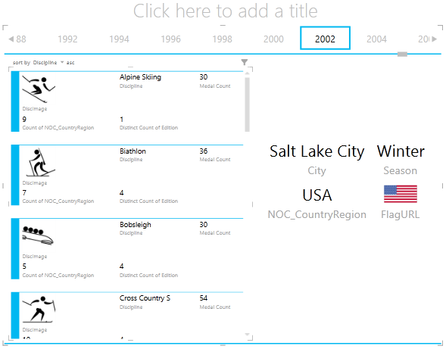
6. You can also change the way Power View tiles information. From the ribbon, select **DESIGN > Tiles > Tile Type > Tile Flow**. The tile visualizations changes, and Power View moves the tiles to the bottom of the tile container, as shown in the following screen.  
   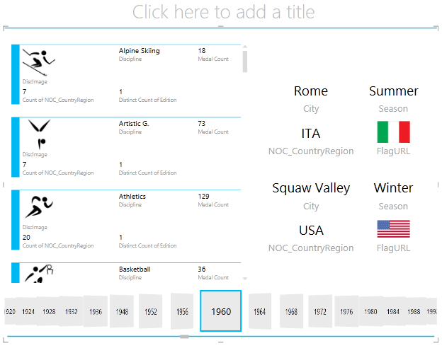

As mentioned previously, when you publish these reports and make them available on SharePoint, these visualizations are just as interactive for anyone viewing them.

## Create Scatter Charts and Bubble Charts with Time-based Play Visualizations

You can also create interactive charts that show changes over time. In this section you create Scatter Charts and Bubble Charts, and visualize the Olympics data in ways that will allow anyone viewing your Power View reports to interact with them in interesting and amazing ways.

*Create a Scatter Chart and Bubble Chart*

1. Create a new Power View report by selecting **POWER VIEW > Insert > Power View** from the ribbon. Rename the report **Bubbles**. From the **Medals** table, select Medal Count and NOC CountryRegion. In the FIELDS area, click the arrow beside NOC\_CountryRegion and select Count (Distinct) to have it provide a count of country or region codes, rather than the codes themselves. Then from the **Events** table, select Sport.
2. Select **DESIGN > Switch Visualization > Other Chart > Scatter** to change the visualization to a scatter chart. Your report looks like the following screen.  
     
   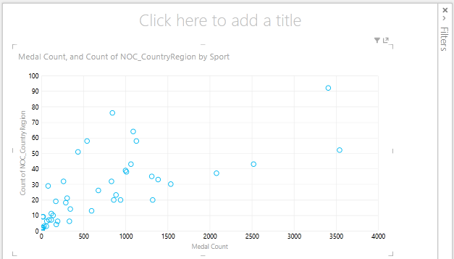
3. Next drag Event from the **Events** table into the SIZE area of **Power View Fields**. Your report becomes much more interesting, and now looks like the following screen.  
     
   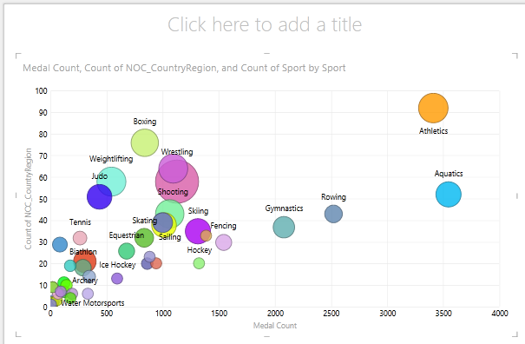
4. Your scatter chart is now a bubble chart, and the size of the bubble is based on the number of medals awarded in each sport.
5. Your bubble chart is interactive too. When you hover over the Rowing bubble, Power View presents you with additional data about that sport, as shown in the following image.  
     
   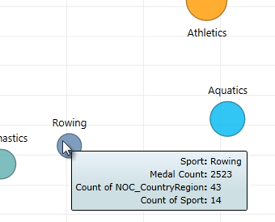

*Create Time-Based Play Visualizations*

Many of the visualizations you create are based on events that happen over time. In the Olympics data set, it’s interesting to see how medals have been awarded throughout the years. The following steps show you how to create visualizations that play, or animate, based on time-based data.

1. In the Scatter Chart you created in the previous steps, notice the PLAY AXIS area in Power View Fields, as shown in the following screen.  
     
   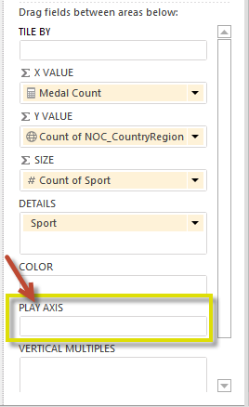
2. From the **Medals** table, drag Year to the PLAY AXIS area. Here comes the fun part. An axis is created along the bottom of the scatter chart visualization, and a PLAY icon appears beside it, as shown in the following screen. Press play.  
     
   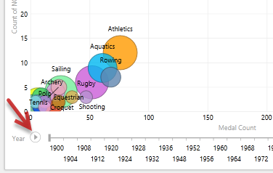
3. Watch as the bubbles move, grow, and contract as the years move along the Play axis. You can also highlight a particular bubble, which in this case is a particular Sport, and clearly see how it changes as the Play axis progresses. A line follows its course, visually highlighting and tracking its data points as the axis moves forward.
4. Select Aquatics, then click Play. Aquatics is highlighted, and a watermark in the upper right corner of the report displays the Year (the PLAY axis) as the PLAY axis moves ahead. At the end, the path Aquatics has taken is highlighted in the visualization, while other sports are dimmed. The following screen shows the report when the Play axis completes.  
     
   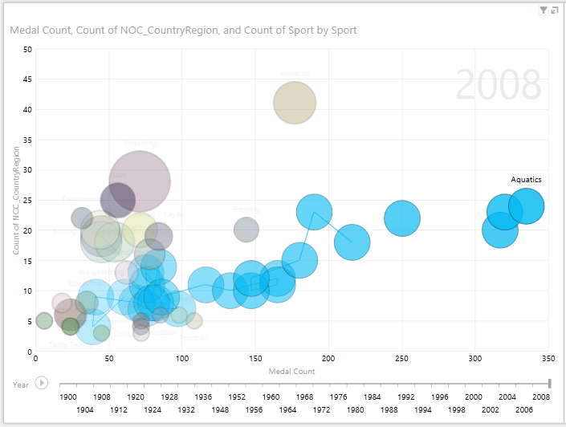
5. You can select more than one sport by holding the CTRL key and making multiple selections. Try it for yourself. In the following screen, three sports are selected: Wrestling, Athletics, and Aquatics.  
     
   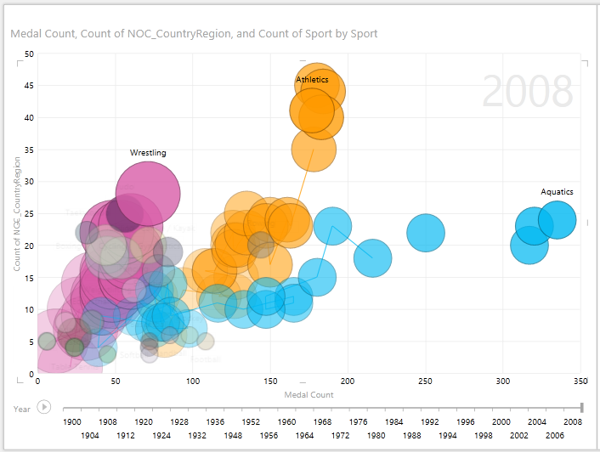
6. Lastly, you can filter Scatter charts just like any other visualization. There are a lot of colors, because there are a lot of sports in the data set. From the **Medals** table, drag Season into the COLOR area of **Power View Fields**. Now only two colors are used, one for each Season (Summer or Winter). The following screen shows this, but to see how cool this looks, watch the video at the end of this tutorial.   
     
   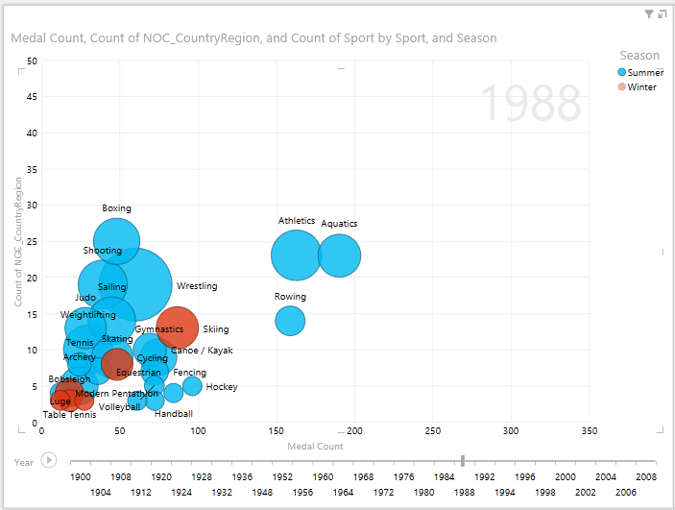

There are all sorts of amazing, compelling reports you can create with Power View. Each visualization brings a certain and distinct view onto your data. To provide even more compelling reports, you can combine different visualizations on a single report page, and make your data come alive.